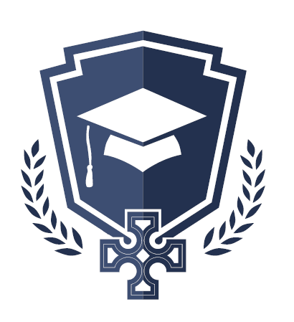
St. John’s National School, Shannon
ANNUAL ADMISSIONS NOTICE
in respect of admissions to the 2024/2025 School Year
Admission Policy and Application Form
A copy of the school’s Admission Policy for 2024/2025 school year is available online at www.stjohnsnationalschool.ie. Please contact the school for an application form.
PART 1 - Admissions to the 2024/2025 school year
Application and Decision Dates for admission to St.John’s National School 2024/2025
The following are the dates applicable for admission to Junior Infants
The school will commence accepting applications for admission on | 1stOct. 2023
The school shall cease accepting applications for admission on | 1st Feb. 2024 at 3pm
The date by which applicants will be notified of the decision on their application is | 6th Feb. 2024
The period within which applicants must confirm acceptance of an offer of admission is | 12th Feb. 2024

Note: the school will consider and issue decisions on late applications in accordance with the school’s admission policy.

Failure to accept an offer within the prescribed period above may result in the offer being withdrawn.

