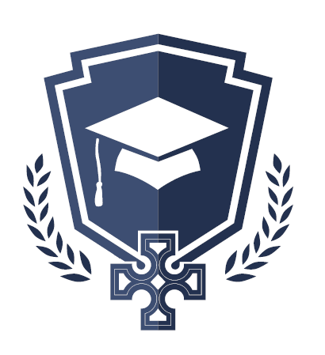
St. John’s National School
Drumgeely Avenue,
Shannon,
Co Clare.
V14Y970
www.website.com

School costs 2023/2024
Payable on Aladdin connect in August

The cost per child for the coming school year will be:
- €45 for one Child.
- €70 for two Children.
- €100 for three Children.

This covers:
- Printing and photocopying
- 24hr pupil personal insurance
- Arts and crafts material
We would ask the Parents to pay as promptly as possible at the beginning of the School year. If you have any difficulties, please contact Kevin in the strictest confidence.

