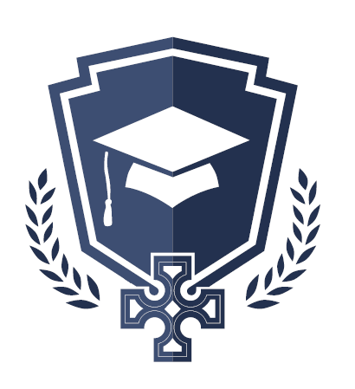
St. John’s National School
Drumgeely Avenue,
Shannon,
Co Clare.
V14Y970
www.website.com

What to bring to school each day:

- As much water as your child will need (minimum one bottle per day – reusable containers preferred)
- Healthy Snack and Lunch.
- Coat or jacket every day.
- School bag with homework completed when issued. (we would ask that no school books are left at home in any circumstances)
- Any child who would like a Friday shop lunch should bring €1 every Friday.

